# Introduction to Game Design

* Primary motivation to start/keep playing:

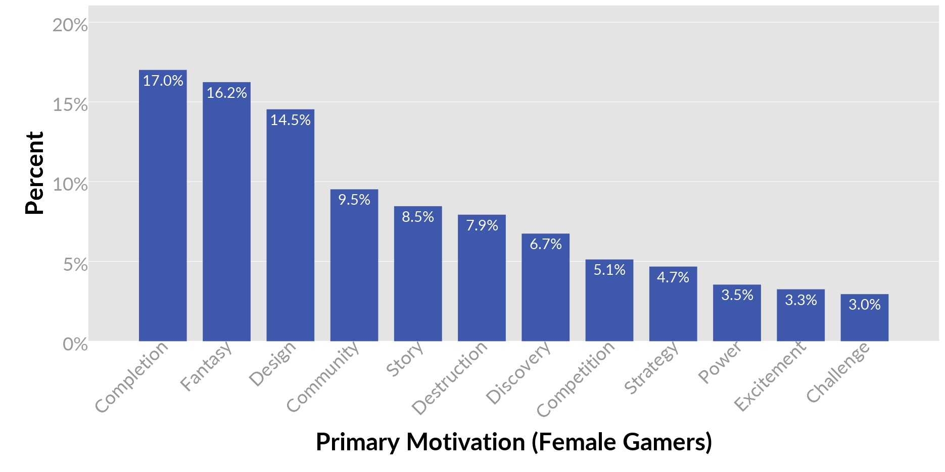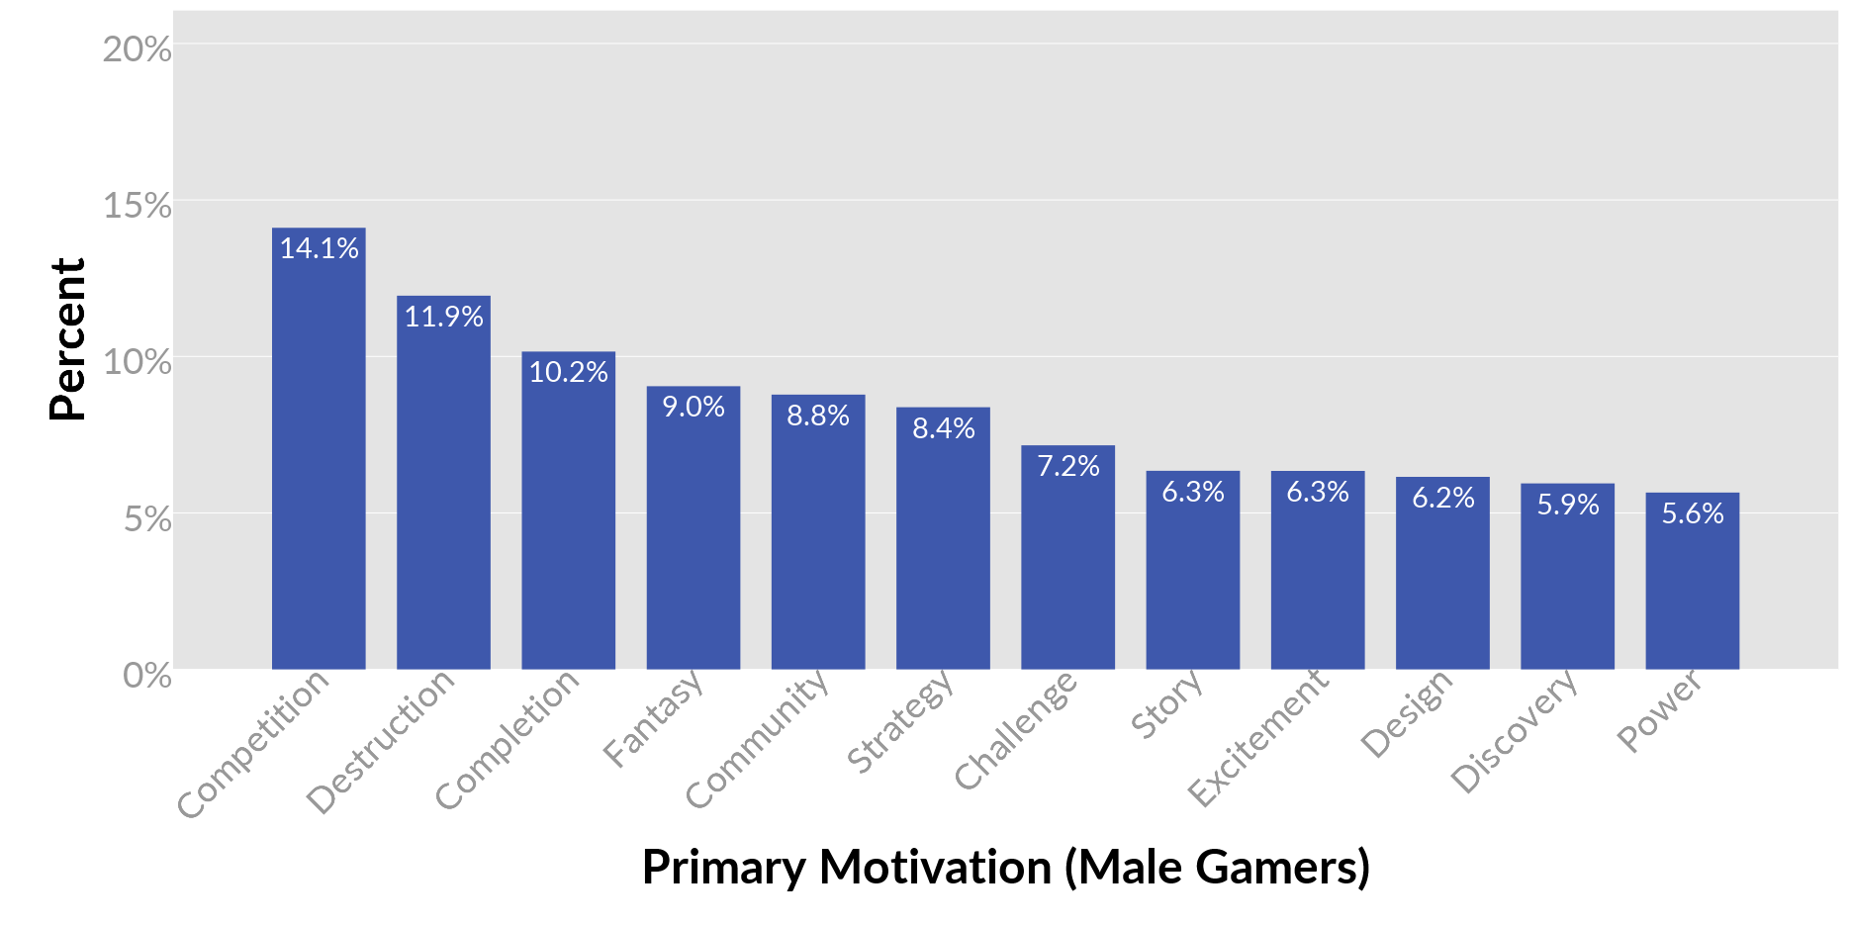

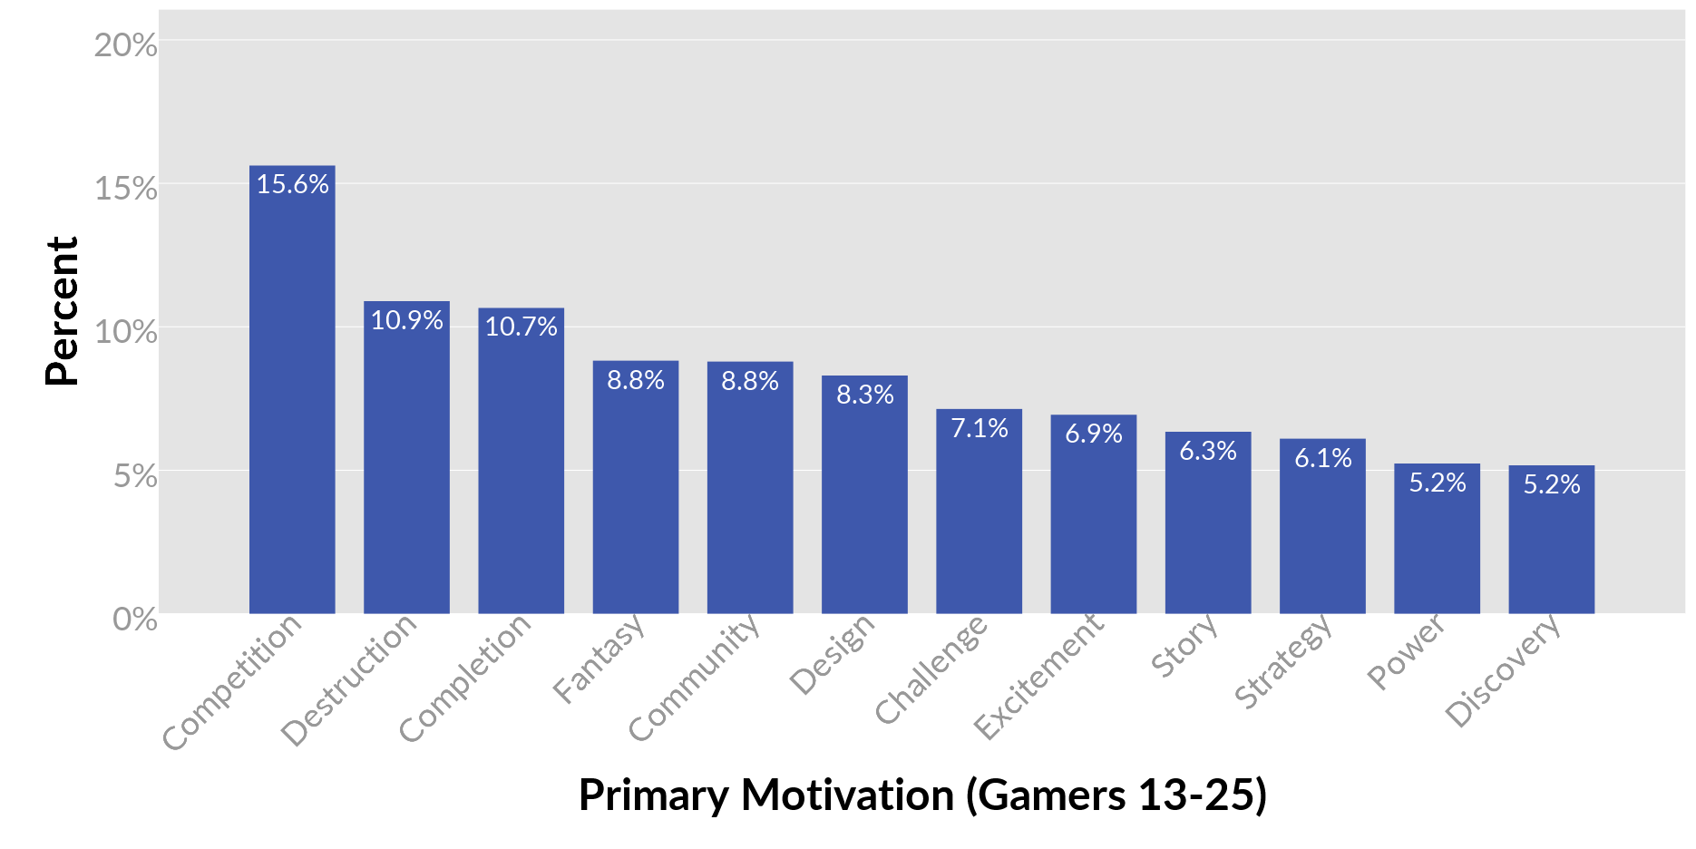

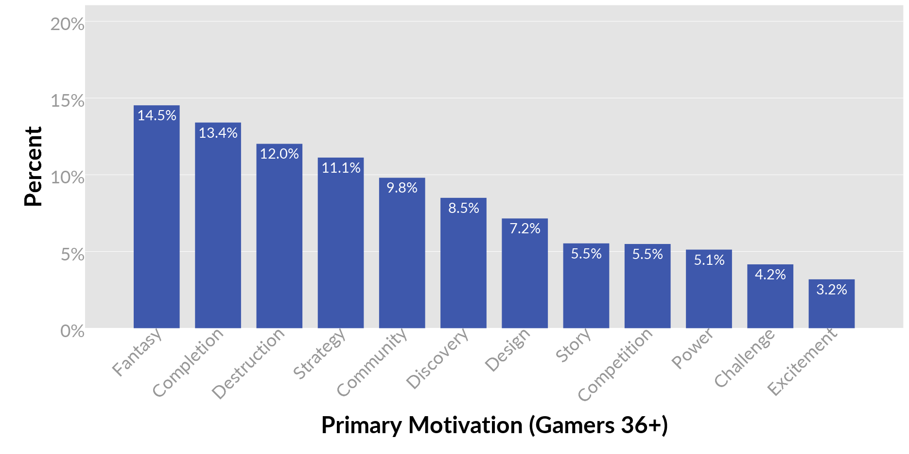

* The flow state is an altered state of consciousness where the player is absorbed in playing and experiencing the game.
* Game designers try to get players in the flow state by challenging the player enough that the game remains interesting and makes them want to keep playing, the trick is to make it not so hard that it is not fun anymore, and not so easy that it becomes boring.
* Maintaining a flow state in gameplay can be challenging because some players master skills faster than others, so it’s better to have a real-time in-game difficulty tweaking mechanic.
* In more difficult to master games, designers try to keep players on the edge of success and failure. This results in a thrilling, rewarding, confidence-boosting, and extremely engaging experience.
* Once a person has been voluntarily conditioned to expect a reward, they will be strongly motivated to continue to pursue it, even when the reward is given to them infrequently.
* Conditioning significantly extends a player’s playing time and is used as an engagement and retention tactic.

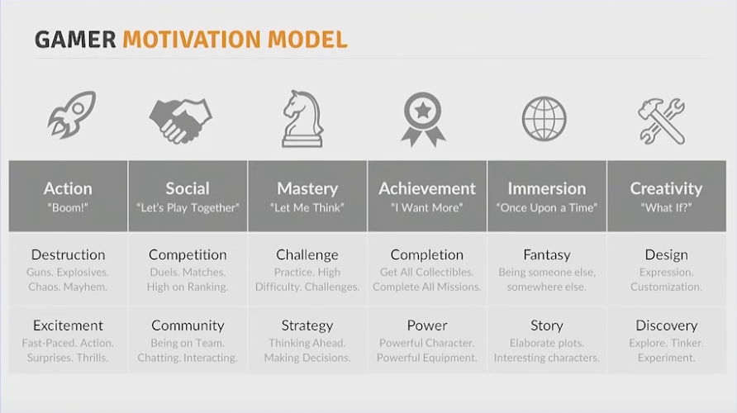

* The audience wants to work for the next piece of the story and deliberate absence of key information in instrumental.
* The player’s drive to obtain information increases engagement with the story.
* From the get-go, design the story with the goal of impacting the player emotionally.
* No holds are barred when creating an impactful story.
* Give enough screen time and space for each story thread and don’t rush.
* Create human-like, not intense moments when players can create and strengthen bonds with characters.
* Construct dilemmas and ambiguous situations, unclear and open to the player’s interpretation.
* Set up the stakes properly before the key choice moment.
* Design for the visibility of consequences; investing in something not telegraphed well is mostly not worth it.
* Details are amazing only when they matter and there is a meaning behind them
* Give players scenarios so bold they wouldn’t expect them.
* Gameplay situations/scenarios/quests/missions provide levels of depth and meaning around what the player is doing, why they are doing it, and why the game world is the way that it is. It hugely effects the player retention and overall game,
* The pillars of a game define the mechanical and emotional experience the designers hope to create, and so are an important first step in the design process.
* Game loop structure -
  + Anticipation – the user anticipates some desired future state.
  + Action – the action is the specific activity we want to incentivize and condition as part of the overall behavior.
  + Reward – we give the user a reward for doing the specific action, thus encouraging them to perform the action again.
* Balancing a challenge so that it requires a measure of both skill and luck is a core element of good game design.
* The dynamic between risk versus reward is one of the most powerful tools a game designer has to make a game interesting and emotionally engaging for their target players.
* Tension between risk and reward emotionally engages and motivates your players to act and move forward.
* Rewards are always a better tool for behavior reinforcement than punishments. Whenever possible, use rewards to encourage and motivate players.